ON-LINE REG. PAYMENT HELP
ACADEMY & SELECT SOCCER
SPRING 2018

On-line registration payment is now available for all Academy soccer players for the SPRING 2018 season through SPIRIT. We encourage all returning players to use the on-line payment system. If you are new or do not want to use the online payment system then you will need to come to the YMCA and register at the membership desk. On-line payment system will be available through January 26, 2018 until 11:59 pm.

*Payments received on or after January 27, 2018 will incur a $50 late fee

Pre-Academy:
Codes:
8U (2010 & 2011) Boys - 449900 8U (2010 & 2011) Girls - 449909

Fees:
8U Pre-Academy age groups: Facility member - $450.00
Program member - $500.00

Payment Plan:
Three payment plan: $250.00 by January 15, remainder of balance split into two equal payments due on February 15 and March 15. Fees must be paid by March 15, 2018.

Academy Boys & Girls:
Codes:
9U (2009) Boys - 449910 9U (2009) Girls - 449911
10U (2008) Boys - 449912 10U (2008) Girls - 449913
11U (2007) Boys - 449914 11U (2007) Girls - 449915
12U (2006) Boys - 449916 12U (2006) Girls - 449917

Fees:
9U – 12U Academy age groups: Facility member - $650.00
Program member - $700.00
Payment Plan:
Three payment plan: $250.00 by January 15, remainder of balance split into two equal payments due on February 15 and March 15. Fees must be paid by March 15, 2018.

Payment Plans:
We offer a payment plan for those who do not wish to pay in full now.
- There is no charge for payment plans
- A credit card is required to set up a payment plan
- We offer a 3 or 5 payment plan depending on Age Groups
- Payment plan requires a down payment of $250.00
- Payment plans will be billed in 30 day intervals
- You are responsible for notifying the Soccer Department if you cancel your credit card (theft) or are issued a new one.

On-line Payment Directions:
For those who have used the on-line payment system before just input your email address and your password. If you do not remember your password and cannot retrieve it from the retrieval link, please call the soccer office (404-371-3316). We can resend your password to you.

For those who have never used our YMCA on-line payment system please follow the below directions to “set-up” your online account:

- Click on "set-up an account"
- Click on "find me" if your child has ever participated in a YMCA program – if not, then create a new account.
- To Find Me - Enter last name, child's birth date who participated in the program, zip code, and then child's personal id number. (Personal id number is found in Spirit and is the number assigned to the individual – do not use the Household number as it won’t work)
- Enter and then it should find their household. Once they find their household then they can finish the process of setting up the on-line account.
- Click on find or register for programs (it will kick you back out of the system and you will need to re-log in)

How to choose payment plan options:
Follow on-line registration as normal by choosing the child and the class and proceed to checkout.
Once you get to the “Registration Charges” (see example below)page follow the below instructions:

- Click on "Bill Method" and choose "Auto Charge" (You must choose auto charge if you want the payment option)
- Choose billing start date of February 15, 2018
- Select “bill me” times - For the Three (3) Payment plan - choose 2. (You will make 2 additional payments after today's initial payment)
- Choose “bill me every 1 month”.
- Click on “Auto Charge Info” to input your credit card information.
- Click on “View Billing Schedule” to view payment amount and date for future payments.
- If you notice a mistake on the billing schedule then you can go back and make changes.

You will be charged $250 for the deposit and that is due at the time of registration. Unfortunately the system will not allow you to change that amount and pay more for the first payment on-line. You can however pay off the full amount sooner than what is set up to auto-charge.

If you are on a scholarship or receive any type of discount (team manager) then you cannot do on-line registration as the system will not allow discounts. You will have to come into the Y to be registered as the staff will have to over ride the system to give the discount.

If you have any questions or problems using the on-line system first click the “Live Chat” button. They can assist you. If you still have issues please call the soccer office at #404-371-3316 or email Kathy Frisbey, kathyf@ymcaatlanta.org , or Paul Wiesboeck, paulw@ymcaatlanta.org.

SEE EXAMPLES:
“Registration Charges Page”
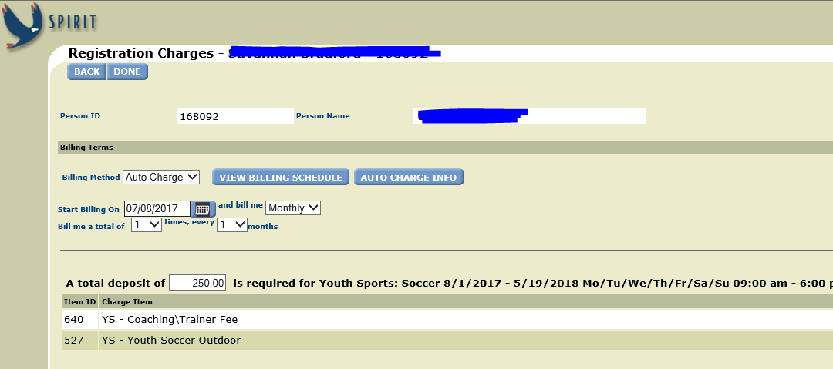

“Billing Method, Bill Date, & Amount of times”
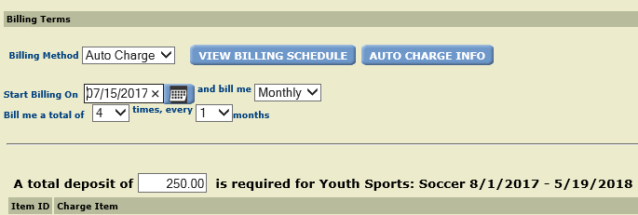

“Billing Schedule Displayed”
